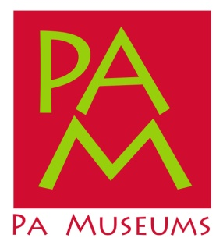
Press Release: PA Museums Conference To Be Held in Centre County
March 1xxxxxxxxx, 2018 (Harrisburg) - Struggling museums and historical sites in Pennsylvania could get a boost from the state if the Pennsylvania Senate moves ahead with a bill to change the way the Commonwealth funds these organizations.
On Monday, June 19 the Senate State Government Committee plans to meet off the floor to consider Senate Bill 755, the Pennsylvania Museum Preservation Act.
“…,…” said Rusty Baker, executive director of PA Museums, a statewide association of museums and historical associations. “……...”
The Pennsylvania Museum Preservation Act was introduced by Senator Pat Browne and Senator Jay Costa on April 7, and the bill closely resembles similar bills (1070, 170, etc.) from the last two legislative sessions. It authorizes the Pennsylvania Historical and Museum Commission (PHMC) to establish a new grant program for museums, and the bill frames new eligibility criteria for organizations seeking funding. More types of organizations would be eligible, and the Pennsylvania Museum Preservation Act also ties definitions and qualitative markers for the Commonwealth’s program to national standards and excellence programs of the American Alliance of Museums (AAM). The measure also increases transparency around museum funding in Pennsylvania.
“PA Museums…..”
About PA Museums
PA Museums is Pennsylvania’s statewide museum association (non profit 501c3) with 350 institutional members across the Commonwealth. Our membership includes museums and historical organizations of many types and sizes, and in addition to providing professional development opportunities for museum professionals, we also lead advocacy campaigns on behalf of the museum community we represent.
Contact: Rusty Baker, PA Museums, (717) 909-4951, mobile (717) 503-5333, rusty.baker@pamuseums.org

