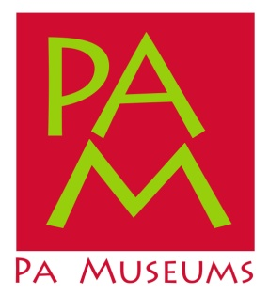
Press Release: Museum Funding Reform Sees Action in Pa. Senate
Senate State Government Committee to Consider the Pennsylvania Museum Preservation Act
June 12, 2017 (Harrisburg) - Struggling museums and historical sites in Pennsylvania could get a boost from the state if the Pennsylvania Senate moves ahead with a bill to change the way the Commonwealth funds these organizations.
On Wednesday, June 14 the Senate State Government Committee will meet at 9:30 a.m. to consider a number of bills including Senate Bill 588, the Pennsylvania Museum Preservation Act.
“This measure shores up policy in support of Pennsylvania’s museums,” said Rusty Baker, executive director of PA Museums, a statewide association of museums and historical associations. “Every dollar invested in museums returns $14 to the state. Funding museums just makes good fiscal sense.”
The Pennsylvania Museum Preservation Act was introduced by Senator Pat Browne and Senator Jay Costa on April 7, and the bill closely resembles similar bills (1070, 170, etc.) from the last two legislative sessions. It authorizes the Pennsylvania Historical and Museum Commission (PHMC) to establish a new grant program for museums, and the bill frames new eligibility criteria for organizations seeking funding. More types of organizations would be eligible, and the Pennsylvania Museum Preservation Act also ties definitions and qualitative markers for the Commonwealth’s program to national standards and excellence programs of the American Alliance of Museums (AAM).
“PA Museums has been supportive of the Pennsylvania Museum Preservation Act since it was first introduced.” said Rusty Baker, executive director of PA Museums. “The PA Museum Preservation Act would be a sound investment in proven organizations – ones that are committed to best practices, serving their communities, attracting tourists, and telling the stories of Pennsylvania for generations to come.”
About PA Museums
PA Museums is Pennsylvania’s statewide museum association (non profit 501c3) with 350 institutional members across the Commonwealth. Our membership includes museums and historical organizations of many types and sizes, and in addition to providing professional development opportunities for museum professionals, we also lead advocacy campaigns on behalf of the museum community we represent.
Contact: Rusty Baker, PA Museums, (717) 909-4951, rusty.baker@pamuseums.org

